Project 3 – Milestone Screenshots
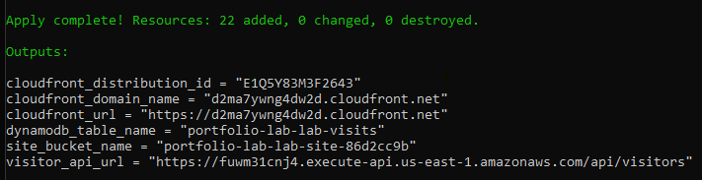
- Static Site implemented successfully
- CloudFront URL - https://d2ma7ywng4dw2d.cloudfront.net
